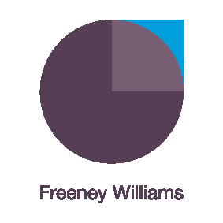
Working from home: for Team Members. Developing emotional resilience and mental wellbeing
We are all learning to work differently in light of the uncertainties presented by Covid-19. Working from home is the new norm but it comes with its own challenges.
This interactive, live workshop is limited to 15 participants and designed to provide individuals working from home with the skills, tools and confidence to develop their own and colleagues’ resilience and wellbeing.
Remote should not mean alone
This Zoom workshop will be delivered by Freeney Williams’ Director, Kerry Smith. Over 90 minutes, Kerry will address questions such as:
- How do we develop the self-awareness to recognise and accept how remote working can impact our wellbeing and performance?
- How do we recognise the signs when anxiety, worries or concerns are adversely impacting us or a colleague, and what can we do to address them?
- How do we develop our own skills, confidence and techniques to enhance our emotional resilience and protect our mental wellbeing?
- How do we have a sensitive conversation remotely with a manager or colleague to raise our concerns?
- How should we stay in touch and stay connected to colleagues and Line Managers?

The workshop will involve:
- Interactive engagement with Kerry Smith and other participants through discussion and text messaging within the Zoom app.
- Pre-workshop activity to facilitate initial discussions
- Supported by further reading
- Topic helpline provided by Kerry following the workshop
- One-to-one online coaching can also be arranged on request – ask for details.
About Freeney Williams
Freeney Williams Ltd, led by Rick Williams, has 20 years’ experience of providing consultancy and training in issues around people’s emotional resilience and wellbeing.
More workshops will follow so keep an eye on our website for more information
For more information, please contact:
Rick Williams CFCIPD
rick@freeneywilliams.com
T: 01273 323949
M: 07788 448428

