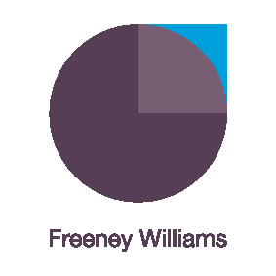
Disabled customers, customer care and Covid-19
We are all learning to serve our customers differently in light of the uncertainties presented by Covid-19. Social distancing is the new norm, but it comes with its own challenges for business and staff.
This interactive, live workshop is limited to 15 participants and designed to provide front-line team members serving disabled customers with the skills, tools and confidence to serve customers whilst maintaining social distancing.
Social distancing doesn’t mean poor customer service for disabled customers!
This Zoom workshop will be delivered by Freeney Williams’ Director, Kerry Smith. Over 90 minutes, Kerry will address questions such as:
- do we need to know whether a customer has a disability??
- how can we make reasonable adjustments in line with social distancing and health and safety?
- how can we identify, understand and address the barriers faced by disabled customers?
- how can we ensure effective and efficient communication with disabled customers while social distancing?
- what practical tools can we use to ensure we serve disabled customers whilst maintaining social distancing?
- how do we explain to a customer that an adjustment they have requested is unreasonable?

The webinar will involve:
- Interactive engagement with Kerry Smith and other participants through discussion and text messaging within the Zoom app.
- Pre-workshop activity to facilitate initial discussions
- Supported by further reading
- Topic helpline provided by Kerry following the workshop
About Freeney Williams
Freeney Williams Ltd, led by Rick Williams, has 20 years’ experience of providing consultancy and training in issues around people’s emotional resilience and wellbeing.
More workshops will follow so keep an eye on our website for more information
For more information, please contact:
Rick Williams CFCIPD
rick@freeneywilliams.com
T: 01273 323949
M: 07788 448428

