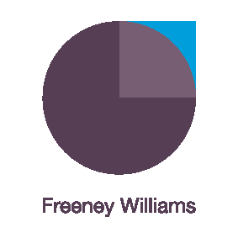
Managing misunderstanding and conflict arising from the new ways of working
This on-line workshop provides tools and develops participants’ confidence and skills in identifying and dealing with those inevitable misunderstandings and tensions between team members, customers and other stakeholders which might arise due to the new ways of working.
Working remotely and social distancing has increased tensions and strains between colleagues and customers. If not addressed, this can become problematic and lead to conflict.
This interactive workshop will be delivered by Freeney Williams’ Director of Consultancy, Clare Cromarty. Over 90 minutes, Clare will address questions such as:
- When and how does tension and conflict arise within teams and with other stakeholders while learning new and different ways of interacting?
- How can we identify and address the underlying issues which arise from unresolved tension and avoid or deal with conflict?
- What might be considered different and acceptable behaviours in these new ways of working?
- How should we decide what are the new acceptable behaviours?
- How do we ensure we are considerate and understanding and accept people will make mistakes?
- How do we facilitate difficult conversations to deal effectively with conflict?

The workshop will involve:
- Interactive engagement with Clare Cromarty and other participants through discussion and text messaging within the Zoom app.
- Pre-workshop activity to facilitate initial discussions
- Supported by further reading
- Topic helpline provided by Clare following the workshop
- One-to-one online coaching can also be arranged on request – ask for details
About Freeney Williams
Freeney Williams Ltd, led by Rick Williams, has 20 years’ experience of providing consultancy and training in issues around people’s emotional resilience and wellbeing.
More workshops will follow so keep an eye on our website for more information
For more information, please contact:
Rick Williams CFCIPD
rick@freeneywilliams.com
T: 01273 323949
M: 07788 448428

